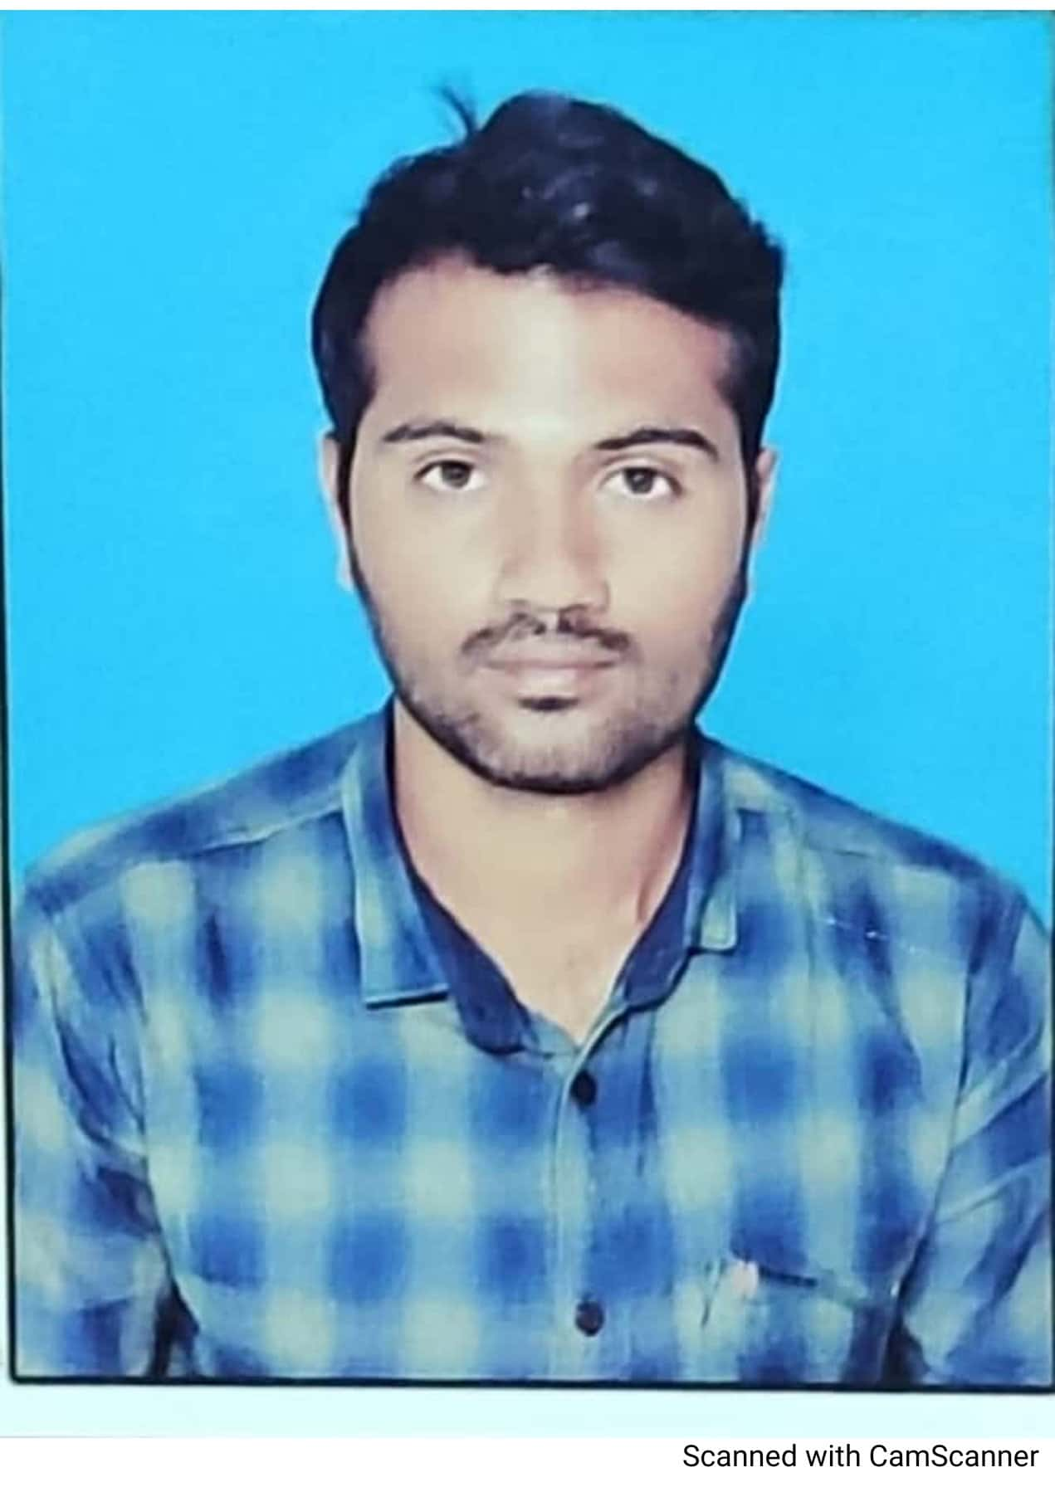

**Professional Summary**

* Business Management
* Decision Making
* Resource allocation
* Managing Development
* Performance Reviews
* Problem Solving

**Education**

* B.Com (Commerce) in 2018.

**Experience**

* Trainee Software Intern at VMR CLOUD SOLUTIONS PVT.LTD from Feb-2018 to July-2018.

**Project**

**Project Name:** TATA PLAY

**Project Summary:**

* Established work procedures and processes that support company and departmental standards, procedures, and strategic directives
* Managed talent through coordinating and facilitating training and identifying development needs
* Provided statistical and performance feedback and coaching, and administered performance reviews for skill improvement
* Built partnership and worked collaboratively with internal resources and external vendors

+91 7330870185

**MALIGALI KALESHA**

**ADDRESS:**

1-154/2,  
Yallamanda Cross,  
Piler,  
Chittoor Dist

**PHONE**

**EMAIL**

Leadership

Team Management

Customer Service

**SKILLS**

* Listening to Music
* Playing Group Games

**LANGUAGES**

ENGLISH

TELUGU

HINDI

**HOBBIES**

**CONTACT**

Kaleshamaligali4@gmail.com